Covid early treatment/Vax after-effects protocols.

The below is a collection of info endorsed by many who have tried these methods and is offered only for your interest and investigation – we take no responsibility for the accuracy of this info or for any effects from its use.

As always – do your own research before undertaking any protocol/treatment.

From The World Council for Health amongst others.
https://worldcouncilforhealth.org/resources/early-covid-19-treatment-guidelines-a-practical-approach-to-home-based-care-for-healthy-families/?utm_source=newsletter&utm_medium=email&utm_campaign=update#symptoms

Other great Protocols to look at are
FLCCC i-mask+
https://covid19criticalcare.com/wp-content/uploads/2020/11/FLCCC-Alliance-I-MASKplus-Protocol-ENGLISH.pdf

The Zelenko protocol
https://vladimirzelenkomd.com/treatment-protocol/

Immune support:
Multivitamin
Vit C and D3
Zinc
Quercetin
Melatonin

Additional support: These are things to have on hand if possible but you don’t have to take everything.

Shikimic acid from these sources help prevent blood clots forming.
Star Anise (has larger amounts of shikimic acid than pine).
Pine tea, (must check the specific pines, because not all pines are safe).
Fennel
Shikimic acid can be overused so research dosages.

Colloidal silver- not ionic silver

Anti viral:
Ivermectin
Doxycycline
Hydroxychloroquine
If symptoms are mild, you might just use one of these,
If they get more intense, doctors tend to use a couple of them together.
The trick is to treat the virus early so it doesn’t take hold in the lungs

Quinine -can be made from a couple of sources. It can be used if there is no access to hydroxychloroquine.
You can use this recipe to make your own quinine water which can be used for any kind of repiratory illness. (people I know have had a good response to this)
3 grapefruit (or five lemons) . Take the peels (wash if not organic)
Put in a pot and pour enough water to cover peel by about 7.5 cm
Bring to boil and simmer for two hours.
DO NOT LIFT THE LID UNTIL POT IS COMPLETELY COLD
(the active ingredients are in the steam)
To use pour into a glass jar (store in fridge) and just have a mouthful every half hour
Stop taking when symptoms disappear.
Grapefruit is better than lemon and taking a zinc supplement will encourage cellular uptake and give you a faster result

https://principia-scientific.com/how-to-make-quinine-water-covid-prophylactic/
Grapefruit skins
Cinchona bark
CoQ10 also has quinine in it.
Tonic water

Antiviral supplements: (Do a search on these, they have some promising results!)
Lysine
Lactoferrin

Mouthwash and nasal rinse:
Great for getting rid of those viral loads carried in the nose and mouth and throat

1.5g baking soda
1g salt
150ml water
Method:
Dilute with 150ml warm water
Gargle for 30 seconds, do not swallow.

To clean out nasal passage
Put mixture into an old fashioned tomato sauce bottle with a pointy nozzle and squeeze water into one nostril while holding head on the side over a basin.
Water will run out the other nostril.
When you are half way through swap nostrils.

(it takes a bit of getting used to…)

Recently there has been research that if you add Betadine (iodine) tincture to the mixture this will effectively eliminate the virus from you nasal passages and throat. Can help to immensely reduce viral load.

Colloidal silver can also be sprayed up your nose and used in the same manner

Anti-inflammatories:
Ibuprofen
N-Acetylcystine -NAC You can still buy through Tasman Health.
L-cysteine
You can use L-cystine instead of NAC : there is a debate about which is better for helping the body make glutathione. Also take a multivitamin with B6, B12 and folate so it can make glutathione.

Antihistamines:
Razene
Loratadine

Anticoagulant:
Aspirin - helps with the blood clotting issues.

Other things:
Paracetamol: WARNING: There have been researchers discovering foreign drugs and objects in pain killers and other meds so use with caution.
Cough meds
Crushed raw garlic

MMS and CDS: Miracle mineral solution and Chlorine dioxide solution
Research of Dr Andreas Kalcker: successful against covid in 100% of his patients treated with these protocols.
https://andreaskalcker.com/en/

Email these people to order MMS and CDS..(NOTE: It is coming from NZ! (Also available from Aus.) It hasn’t been discovered yet and isn’t being suppressed and removed, so take advantage and get some! )

info@nzwaterpurifier.com
https://www.nzwaterpurifier.com/index.cfm?fact=product

I read somewhere that a litre of MMS/CDS should last a family of four for a year.
Make sure you download and read the protocol.

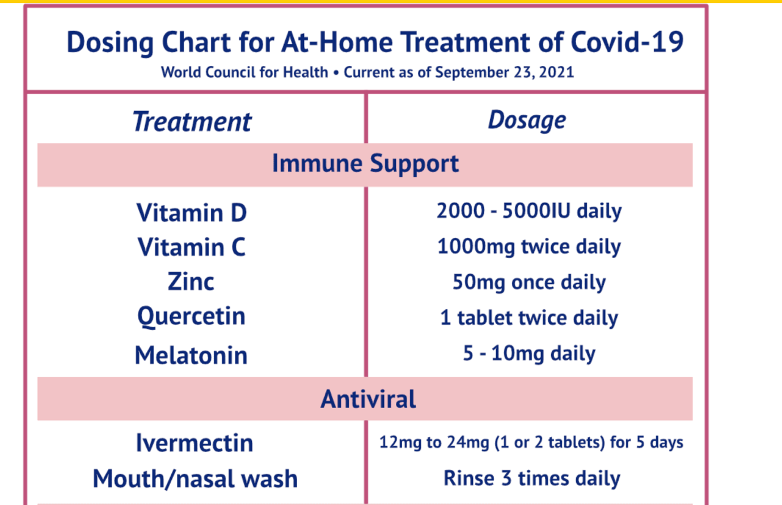

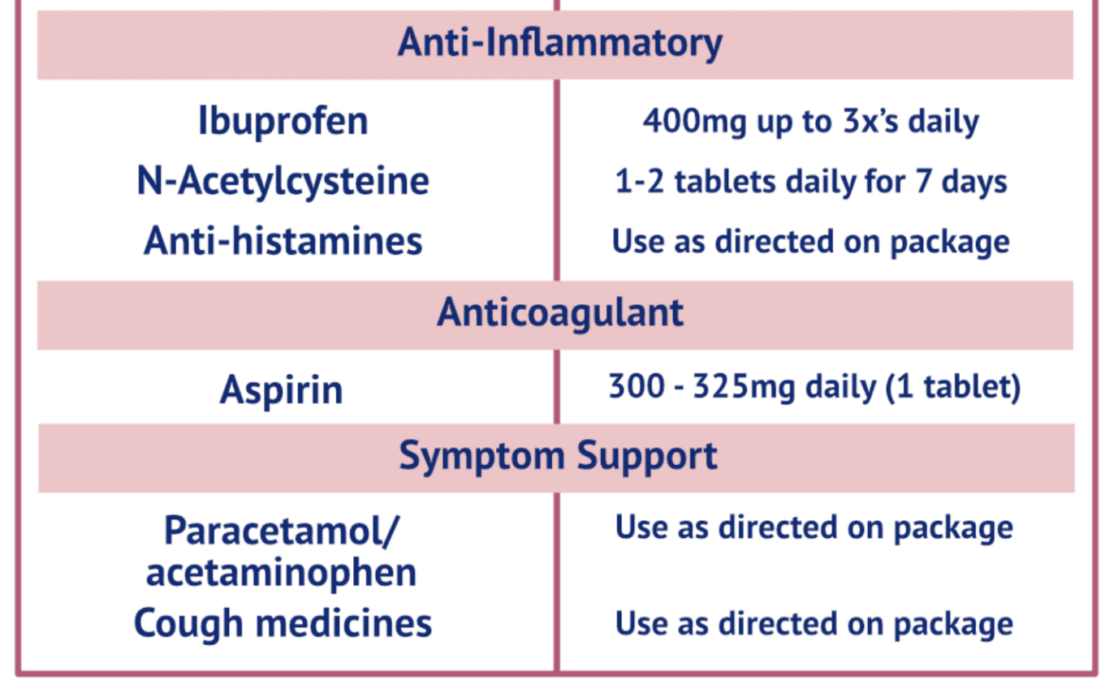

How to Detox from the injection:
(you don’t have to do all of these).

First of all FAST.
Try to do a three day water fast.
This is a way to switch on autophagy in the body.
A process that begins to destroy, gobble up, remove anything that is waste or not functioning correctly.

Fasting seems to have had the effect of removing the spike protein and taking away the unwanted genetic material.

https://deeprootsathome.com/the-spike-protein-protocol-what-we-all-can-do-to-stay-healthy/?utm_source=newsletter&utm_medium=email&utm_campaign=spike_protein_protocol_what_we_can_all_do_to_stay_healthy&utm_term=2021-10-06

Low dose aspirin for reducing blood clots
(its similar to the covid protocols)

NAC or L cysteine
Quercetin
Vitamins D3,
Vit C. effective for reducing Graphene Oxide toxicity
Zinc, B complex

Fulvic and hulmic acid for detoxing heavy metal
C60 for detoxing

Chlorella, chlorophyll, spirulina (good for detox)
Super blue green algae chelates blood and removes heavy metals
Can also use greens such as coriander, cilantro, parsley

Dandelion tea (acts against the ACE2 receptors)
Pine needle tea: Reduces platelet aggregation with shikimic acid (reduces blood clots)
(not all pines needles are good. Do a bit of research on that)
Or star anise tea ( actually has more shikimic acid than pine tea.)

Antiparasitic- Ivermectin would be ideal but if you cant get that
Nigella sativa seeds (Black cumin seeds) seem to have some proof of efficacy.
Mixed 1:1 1g/kg body weight honey (pref manuka) and 80mg/body weight NigellaSativa
Heat seeds to 50-150c (not above) then make into a powder and mix with honey.
Seems like a bloody lot of honey and seeds to me!
Some are suggesting the ratio is the same for the honey but only 40g/kg body weight for the seeds. Try and do some research or experiment.
Some if the research was done using the Black seed oil instead.

Iodine: Increases mRNA decay rate and detoxifies toxic compounds

CDS: neutralizes and eliminates spikes

Rooibos tea: strong antioxidant (1c rooibos is equal to 50 c green tea)

PQQ: Pyrroloquinoline quinone: (supplement). generates new mitochondria

Bentonite clay ½ tsp in water daily
Activated charcoal drink up to 12 glasses of water a day.

Hydrate during day
With alkaline water: 2 litres water , squeeze of lemon juice and a couple of pinches of Himalayan salt.

Also check out this website https://earlycovidcare.org/

